**“Experiment 1.3”**

Student Name: **SUMIT KUMAR**  UID: **20BCS8226**

Branch: **CSE** Section/Group: **808 A**

Semester: **5** Date of Performance: **25-08-22**

Subject Name: **Multimedia Technologies Lab** Subject Code: **20CSP-339**

**1. Aim/Overview of the practical:**

Procedure to type a word and apply the effects shadow emboss using Photopea.

**2. Which logistics used:**

Hardware Requirements: - Minimum 384MB RAM, 100 GB hard Disk, processor with 2.1 MHz

Software Requirements: - Photopea

Tools Used: - Type Tool, Bevel and Emboss, Emboss option

**3. Steps for experiment/practical/Code:**

**Step 1:** Create new blank project on Photopea, and specify dimensions as required.

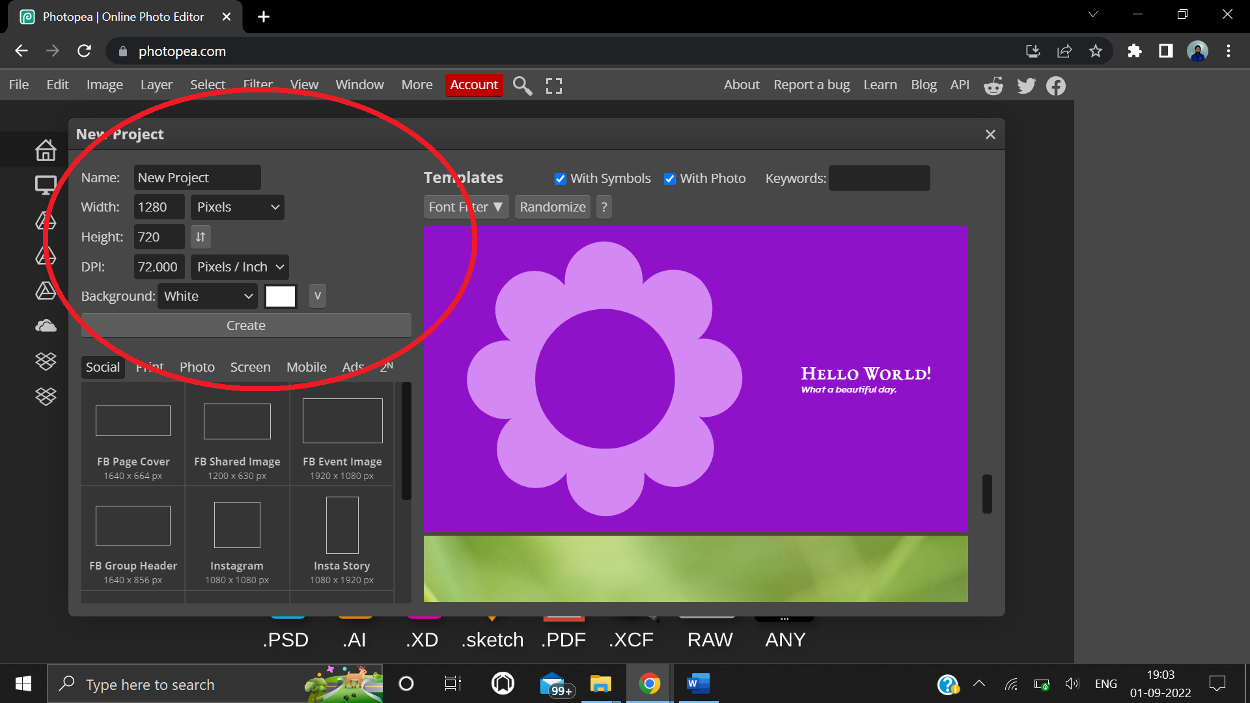

**Step 2:** Add any text in any font with large font size using type tool.

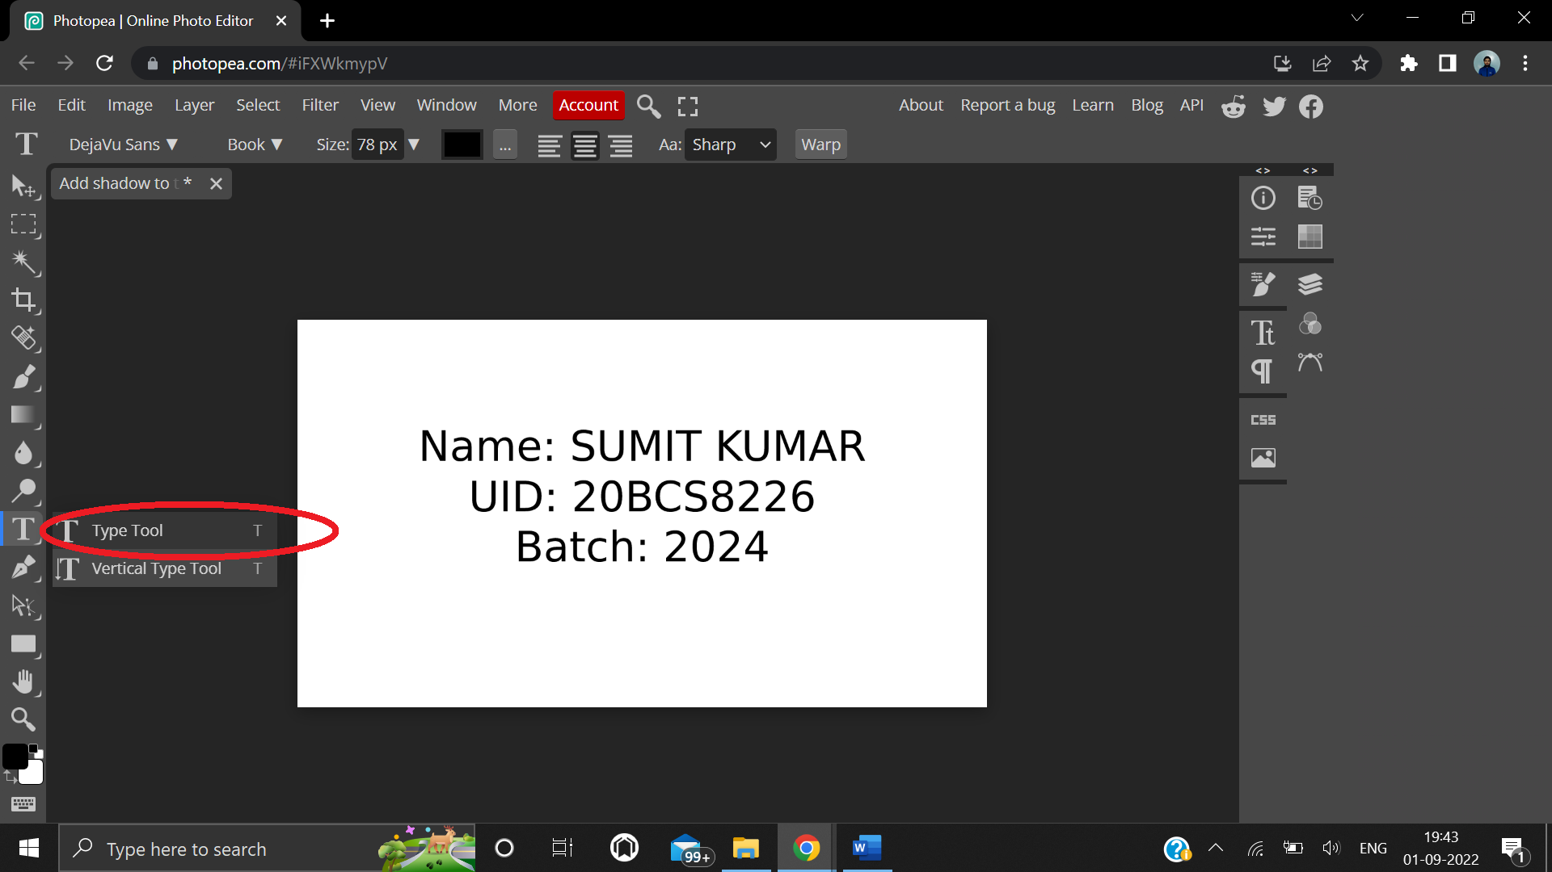

**Step 3:** From the top navbar, click Layer, and select Layer style from the dropdown menu. From layer style select Bevel and Emboss.

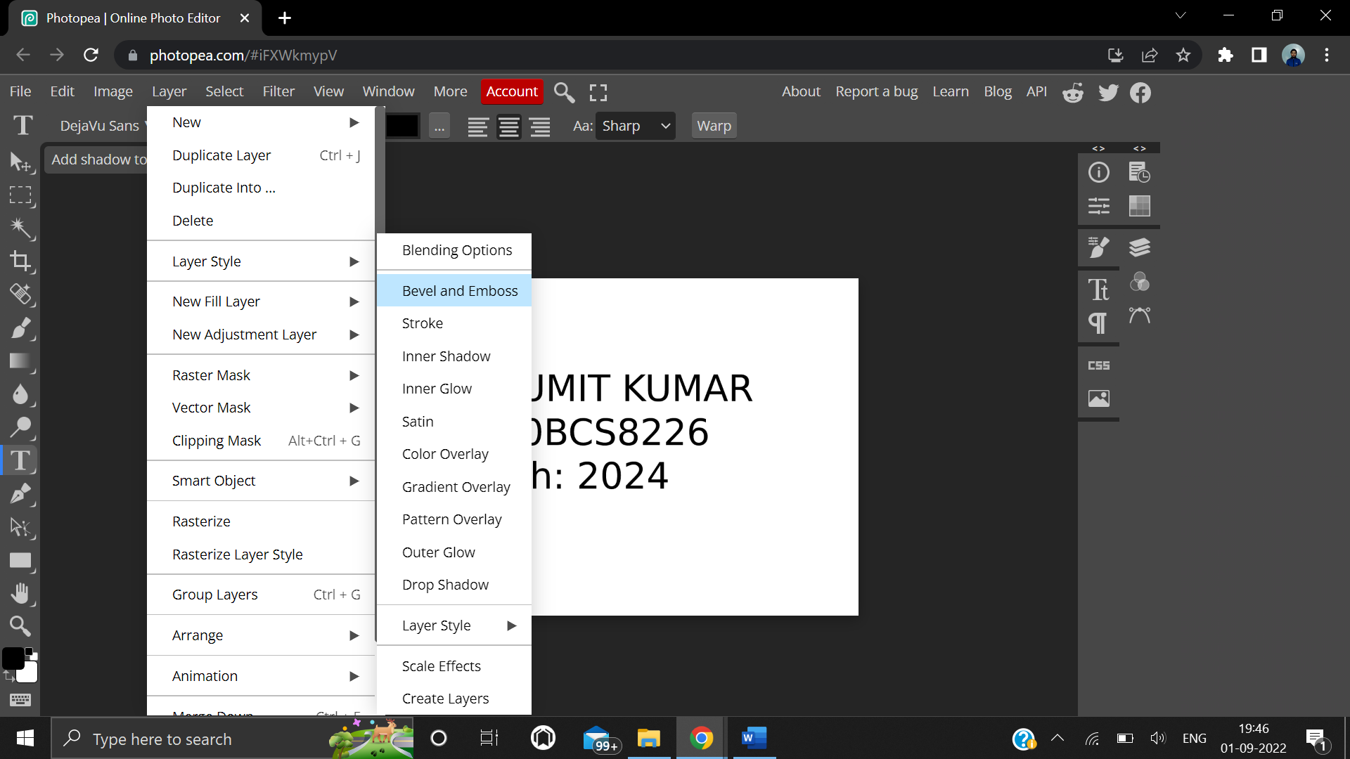

**Step 4:** On the new window that opens, select the drop shadow option on the left hand side to give the text a drop shadow.

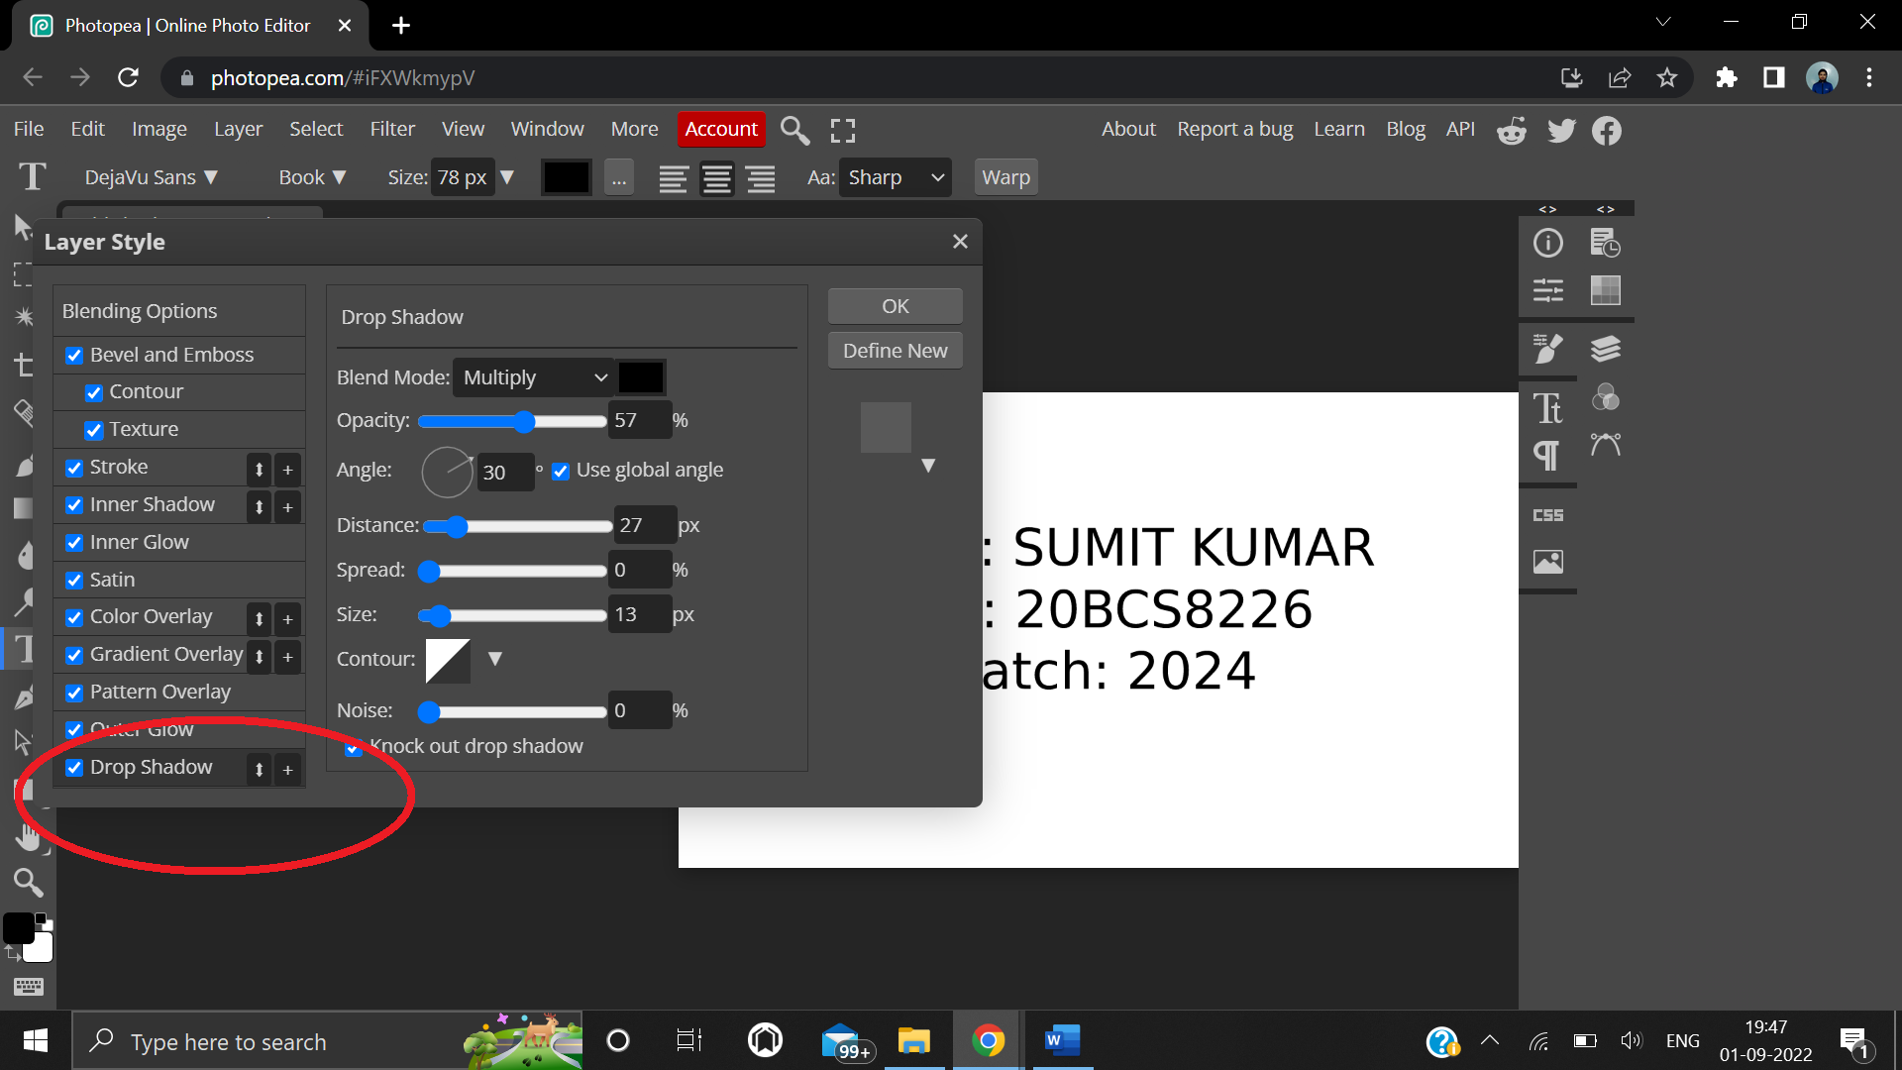

**4. Result/Output/Writing Summary:**

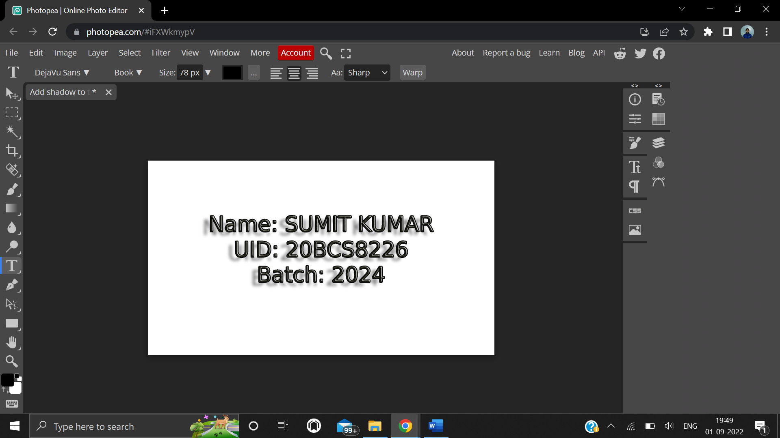

**Text after applying shadow emboss**

**Learning outcomes (What I have learnt):**

**1.** Learnt how to change text size, font, and color on photopea.

**2.** Learnt how to add different effects to text such as bevel and drop shadows.

**Evaluation Grid (To be created as per the SOP and Assessment guidelines by the faculty):**

|  |  |  |  |
| --- | --- | --- | --- |
| Sr. No. | Parameters | Marks Obtained | Maximum Marks |
| 1. |  |  |  |
| 2. |  |  |  |
| 3. |  |  |  |
|  |  |  |  |